Project 5 – Milestone Screenshots

Encounter 1st Error
The screenshot below shows my first error encountered while attempting to execute “terraform apply” in my working clone directory.
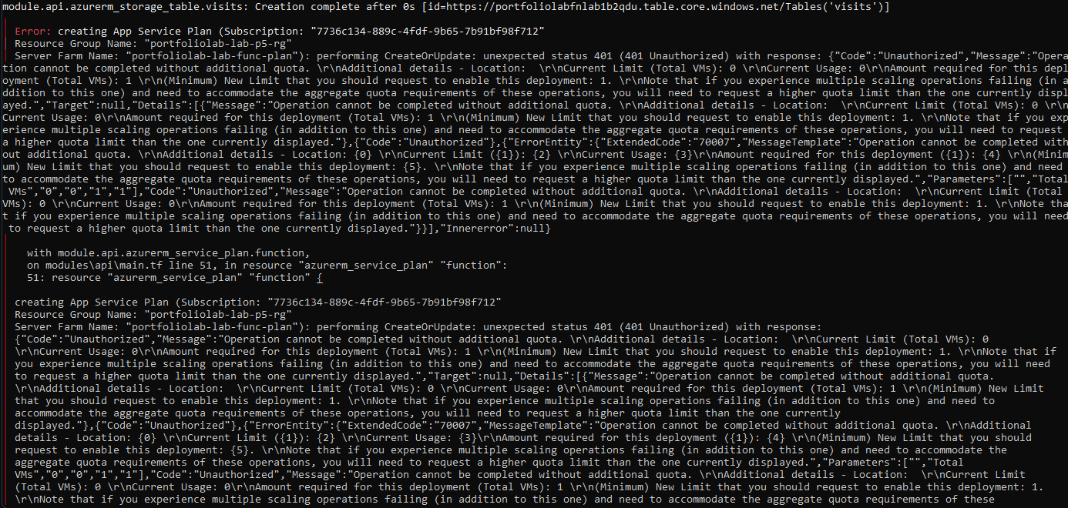
Storage Account in Resource Manager
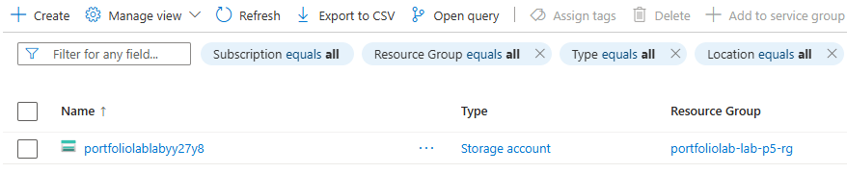
Live Site Hosted on Azure Storage
